Technical Paper: Tech:1-20062012

Project Title: Understanding functional connectivity in resting state: a network based approach

**Phase 1: fMRI data analysis for functionally resting state networks**.

Author(s): Jaime Gomez-Ramirez

Biomedical Engineering Laboratory

Okayama University

**Introduction**

Study brain connectivity using fMRI data presents important challenges that need to addressed in a consistent and theoretically sound way. The project tries to understand the network connectivity topology in resting state. Typically, fMRI studies focus on the changes in BOLD signals related to external stimulus or task, compared to a control condition or baseline. In a resting state study there is no a goal-directed task neither an external stimuli. However fMRI studies can still identify the resting state patterns in the BOLD signal. In appositive note, not having to use a task may be beneficial for example in experiments with Alzehimer’s disease subjects with their motor and cognitive abilities diminished by AD. Before getting into technical details we need to cover a conceptual issue that is key for this project, namely how we deal with the baseline or control state in fMRI.

**What is the baseline or control activity?**

Resting–state analysis is in itself a different paradigm from the goal directed/ external stimulus analysis in fMRI. In a typical goal-directed study, what is really measured is the difference in the fMRI signal between task-period and baseline of control period, that is to say, the resting state is assumed to be the baseline or control state with no functional significance. However, this view has been drastically challenged as recent studies shows that “*the baseline state of the brain is by no means an inactive state”* (Damoiseaux, 2006).

In order to use fMRI to study resting state, we need to identify activity patterns measured by BOLD signals, and whether they can be related to functionally relevant resting state networks. Thus the objective in this phase of the project is to relate resting-state networks to “coherent” resting fluctuations in BOLD signal. Coherent means that the fluctuations need to be consistent between and within subjects. So we need a multisession and multisubject experiment.

**Finding activity patterns relevant to resting state**

It has been suggested that fluctuations in the BOLD signal during rest reflect the neuronal baseline activity of the brain. In (Damoiseaux, 2006) using a ICA-based study they found 10 patterns with potential functional relevance given by a 3% change in BOLD signal in the target areas that the researchers estimate as relevant, such as memory related areas, visual processing, DMN an others.

In what follows I sketch the methods of (Damoiseaux, 2006) to find the spatiotemporal patterns of BOLD fluctuations that are assumed to be related to resting state.

**Preprocessing** (Using FMRIB FSL software)

The sequence parameters in the study are: Repetition time = 2,850 ms; echo time = 60 ms; flip angle = 90°.

Steps:

• motion correction

• removal of nonbrain structures from the echo planar imaging volumes

• spatial smoothing by using a Gaussian kernel of 6 mm FWHM

• mean-based intensity normalization of all volumes by the same factor (i.e., 4D grand-mean)

• high-pass temporal filtering (Gaussian-weighted least-squares straight line fitting) (FWHM =150 s), and Gaussian low-pass temporal filtering (FWHM = 5.6 s).

• affine registration (Does SPM have this features?)

**Methodology: ICA (multiple regression) vs. Single time regression**

ICA-based studies allows to simultaneously decompose into several maps, providing a set of components in which resting state networks can be studied.

ICA doesn’t require predefined ROI or the identification of seed voxel location.

The researchers use Tensor probabilistic ICA (PICA) to simultaneously decompose group fMRI data into modes describing variations across space, time, and subjects in order to resting coherencies consistent across subjects and experiments. The below figure shows 10 components that contain the spatial maps of coherent resting fluctuations. The components have a low frequency in the range of range 0.005–0.030 Hz.

Note that in resting-state experiments we have to work in the frequency domain, because as subjects are not engaged in any particular task we can’t assume any particular time response for the individual components.

We know that resting fluctuations of interest are associated with strong power in the low range 0.01-0.1Hz

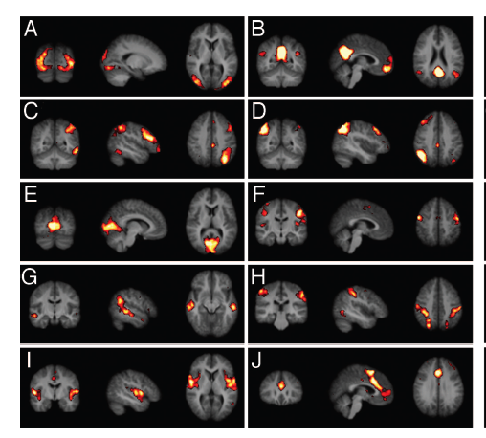

Result of of PICA analysis with 10 components or estimation or resting patterns. The fluctuations are coloured (2%-5%) and represent networks

**Questions to be addressed in the Okayama Lab**

1. For our data set of 24 healthy subjects in resting state; Can we using ICA-based analysis find coherent resting state patterns?
2. The 10 components shown in the paper are spatially independent areas with low frequency fluctuations. However more and or different patterns may be found, and more importantly how the patterns are related needs to be explored. Which consistent patterns can we find with our data? and how to model them as networks? (this question is addressed in the technical paper Tech:2-20062012)

References

J. S. Damoiseaux et al. (2006) Consistent resting-state networks across healthy subjects